
L.J. Institute of Computer
Application
L.J. University

Master of Computer Application - Cybersecurity Specialization

MCA Cyber Security

3rd Semester

Subject Name: Ethical Hacking & Pen Testing

Subject Code: MCACS302

Submitted To: Mr. Avinash Verma

Submitted By: Chudasama Vishal
Roll Number: E02

CERTIFICATE

This is to certify that Mr. Chudasama Vishal Bhimashibhai with enrollment number 25004401110069 Semester 3rd has successfully completed his laboratory experiments in Ethical Hacking and Pen testing (MCACS302) from the department of MCA Cyber Security during the academic year 2025 - 2028

Date of Submission:

Staff in charge: Mr. Avinash Verma

TABLE OF CONTENT
Sr. No | Experiment Title | Page No | Date of Completion | Marks (Out of 10) | Sign
1 | Exploiting Metasploitable [ftp, ssh, mysql] by msfconsole | 4
2 | Brute force attack using Hydra and Burpsuite | 19
3 | Zphisher | -
4 | DVWA exploit [bruteforce, command injection] | -
5 | theHarvester | -
6 | Maltego | -
7 | Google Dorking [site:, inurl:, intitle:, address: and cache:] | 22
8 | Nmap all important options | 28

Practical-1

AIM: “Exploiting Metasploitable [ftp, ssh, mysql] by msfconsole.”

Metasploitable 2 is an intentionally vulnerable virtual machine designed for security testing and penetration-testing practice. Metasploit Framework provides msfconsole, a command-line interface used to identify and test known vulnerabilities. In this practical, the FTP, SSH, and MySQL services running on Metasploitable 2 will be examined and tested using appropriate Metasploit modules. The practical demonstrates how vulnerable services can be identified and how exploitation can be performed in an authorized lab environment.

Step 1: Start the Lab Machines
Start both virtual machines in VMware:
- Start Kali Linux.
- Start Metasploitable 2.
- Make sure both VMs are connected to the same VMware virtual network.
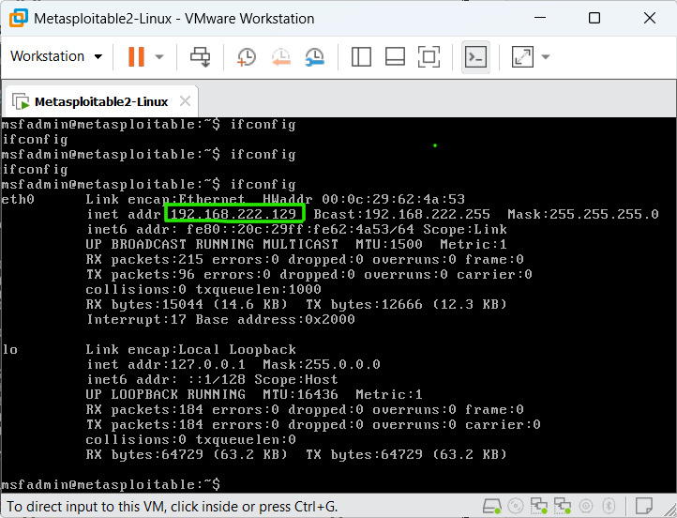
Screenshot 1: Metasploitable 2 IP Address Using ifconfig
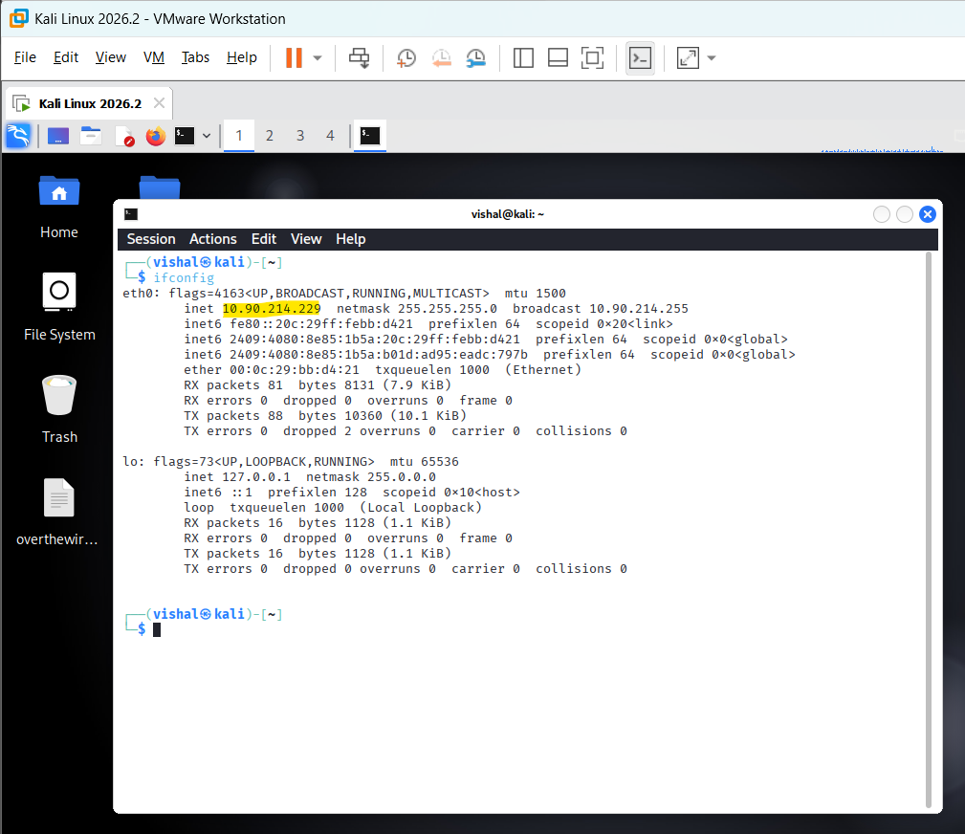
Screenshot 2: Kali Linux terminal showing it's ip address by ifconfig command
Explanation:
The screenshot shows the network configuration of the lab machines. Kali Linux has the IP address 10.90.214.229 (yellow highlight), while Metasploitable 2 has the target IP address 192.168.222.129 (green box). These addresses are used to identify the attacker and target machines during the practical.
Highlight:
- Screenshot 2 the Kali Linux IP address: 10.90.214.229
- Screenshot 1 the Metasploitable 2 IP address: 192.168.222.129
Action:
The identified Metasploitable 2 IP address 192.168.222.129 is used as the target address for subsequent Metasploit testing from Kali Linux.
Step 2: Launch Metasploit Framework
On Kali Linux, open the Terminal and execute: msfconsole
Wait for Metasploit to load. When it finishes, you should see the Metasploit prompt:
msf6 >
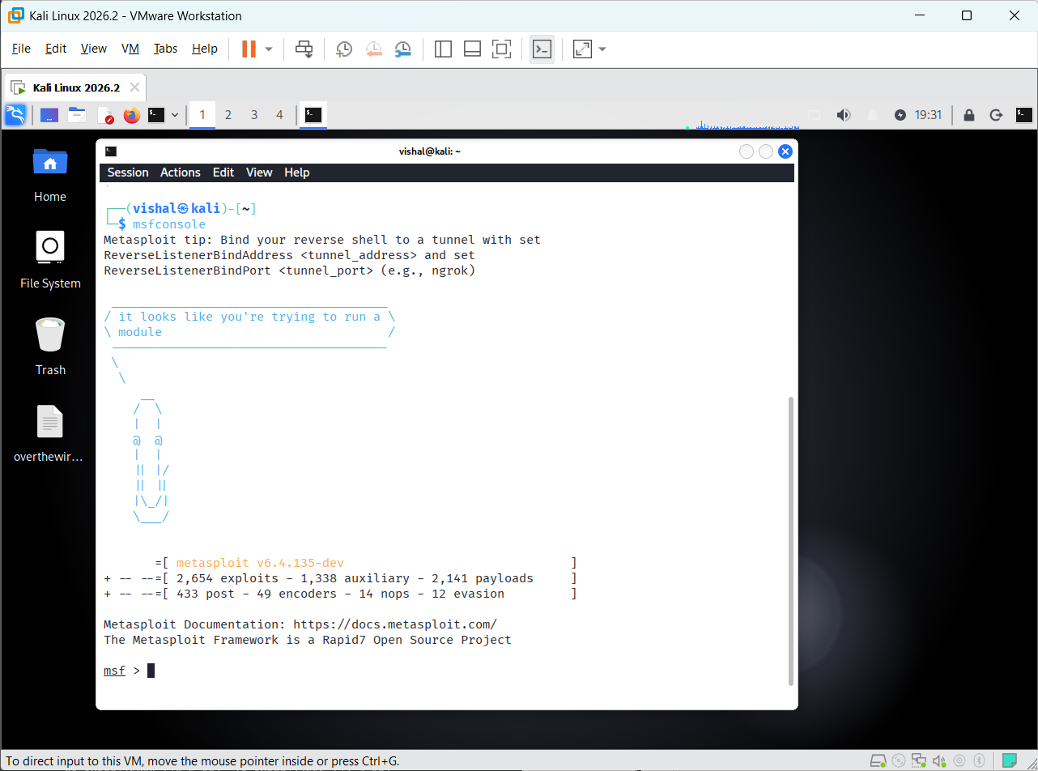
Screenshot 3: Metasploit Framework Console
Explanation:
The screenshot shows the Metasploit Framework successfully launched through msfconsole. The msf6 > prompt indicates that Metasploit is ready to accept commands and perform security testing against the authorized Metasploitable 2 target.
Action:
The Metasploit Framework is initialized and ready for selecting and configuring modules to test the vulnerable services available on Metasploitable 2.

Step 3: Search for FTP Vulnerability
Now that msfconsole is running, we will begin with the FTP service on Metasploitable 2.
At the msf6 > prompt, run: search vsftpd
Metasploitable 2 contains an intentionally vulnerable version of vsFTPd 2.3.4. The search command searches the Metasploit module database for modules related to this vulnerable service.
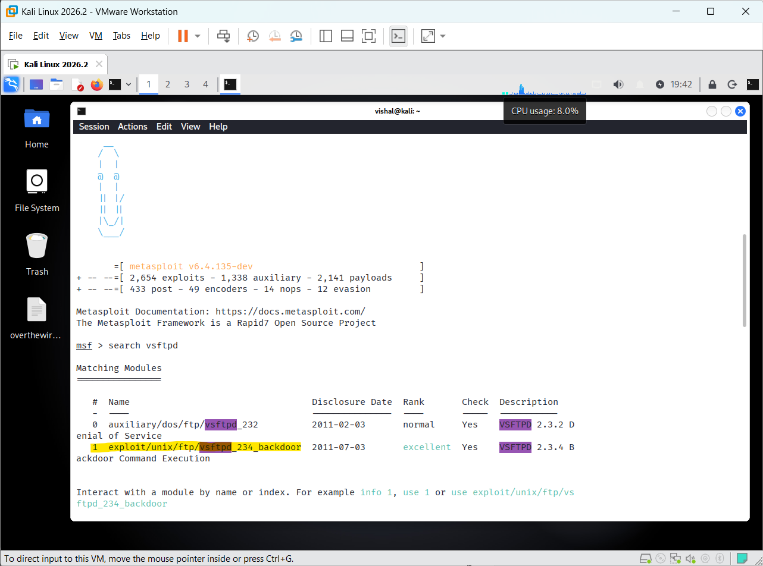
Screenshot 4: Searching for vsFTPd Modules in Metasploit
Explanation:
The screenshot shows the results returned by Metasploit after executing the search vsftpd command. The search identifies available Metasploit modules related to the vsFTPd service, including modules associated with the vulnerable vsFTPd 2.3.4 version.
Action:
The identified vsFTPd-related module is examined to determine its suitability for testing the FTP service running on the Metasploitable 2 target.

Step 4: Select the vsFTPd Backdoor Module
At the msf6 > prompt, execute: use 1
Metasploit will select the module listed at index 1 from the previous search result.
Then run: show options
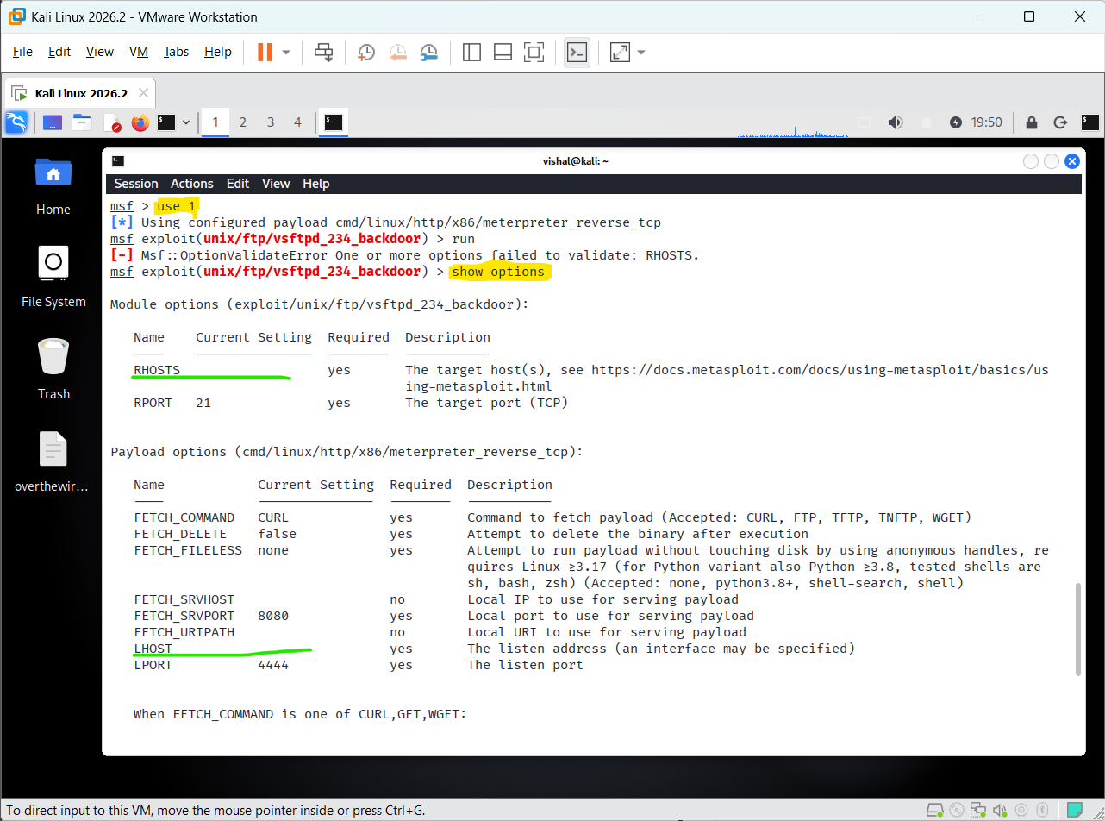
Screenshot 5: vsFTPd Backdoor Module Options
Explanation:
The screenshot displays the configuration options of the selected vsFTPd 2.3.4 backdoor module. It shows the parameters available for configuring the target before executing the security test.
Action:
The module options are reviewed to identify the required target configuration before proceeding with the authorized FTP vulnerability test.

Step 5: Configure RHOSTS and LHOST
5.1 Set the Target IP — RHOSTS
At the current Metasploit prompt, run: set RHOSTS 192.168.222.129
Here:
- RHOSTS = Remote Host(s), meaning the Metasploitable 2 target
- 192.168.222.129 = Metasploitable 2 IP address
You should see: RHOSTS => 192.168.222.129
5.2 Set the Kali IP — LHOST
Now run: set LHOST 10.90.214.229
Here:
- LHOST = Local Host, meaning the Kali Linux machine
- 10.90.214.229 = Kali Linux IP address
You should see: LHOST => 10.90.214.229
5.3 Verify the Configuration
After setting both values, run: show options
Check that:
- RHOSTS → 192.168.222.129
- LHOST → 10.90.214.229
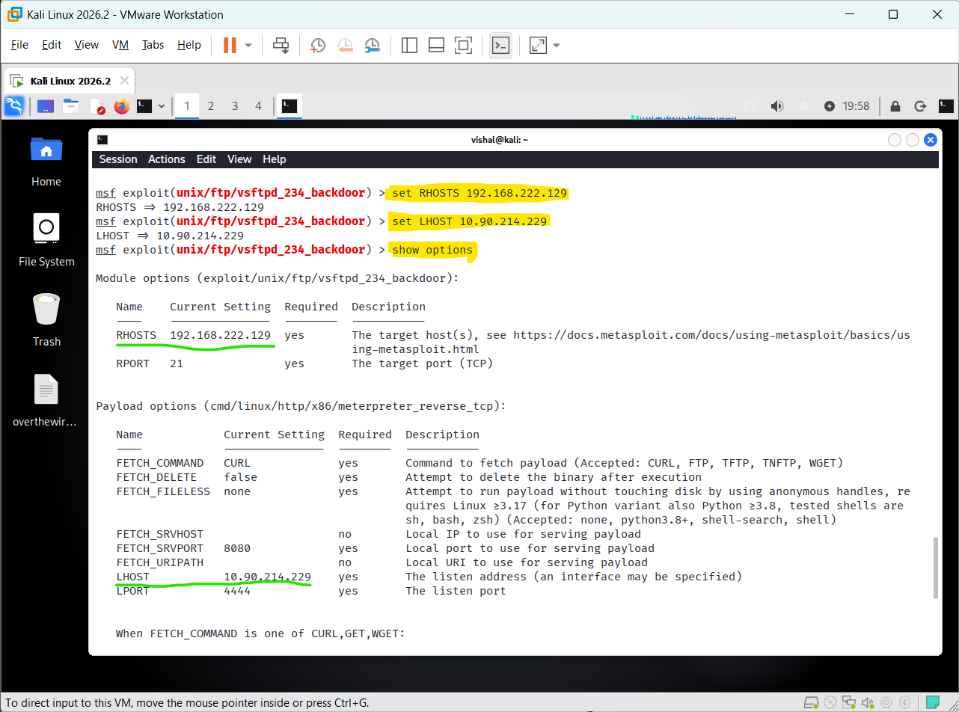
Screenshot 6: Configured RHOSTS and LHOST
Explanation:
The screenshot shows the configuration of the Metasploit module with the IP address of the Metasploitable 2 target specified as RHOSTS and the Kali Linux IP address specified as LHOST. These settings define the target system and the local host used for the subsequent security test.
Action:
The required target and local host parameters are configured, allowing the selected Metasploit module to proceed to the next stage of the FTP vulnerability test.

Step 6: Run the vsFTPd Backdoor Exploit
After configuring the required RHOSTS and LHOST values, execute the selected module using:
run

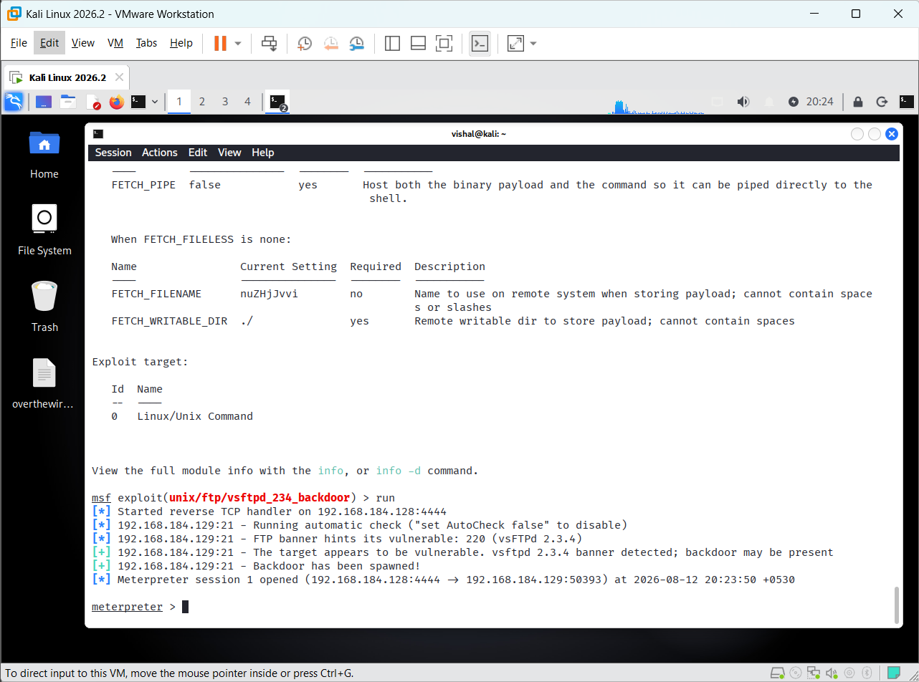
Screenshot 7: Successful vsFTPd 2.3.4 Exploitation
Explanation:
The screenshot shows the successful exploitation of the vulnerable vsFTPd 2.3.4 service on Metasploitable 2. The FTP banner identifies the vulnerable version, and Metasploit reports that the backdoor was successfully spawned. A Meterpreter session is established with the target machine..
A Meterpreter session is successfully established with the Metasploitable 2 target, allowing further authorized security testing to be performed.

Step 7: Identify the SSH Service Version
From the Metasploit console, search for SSH version-related modules: search ssh_version
The search result displays multiple SSH version-related modules. The SSH Version Scanner is selected from the result: use 3
Then display the module configuration: show options
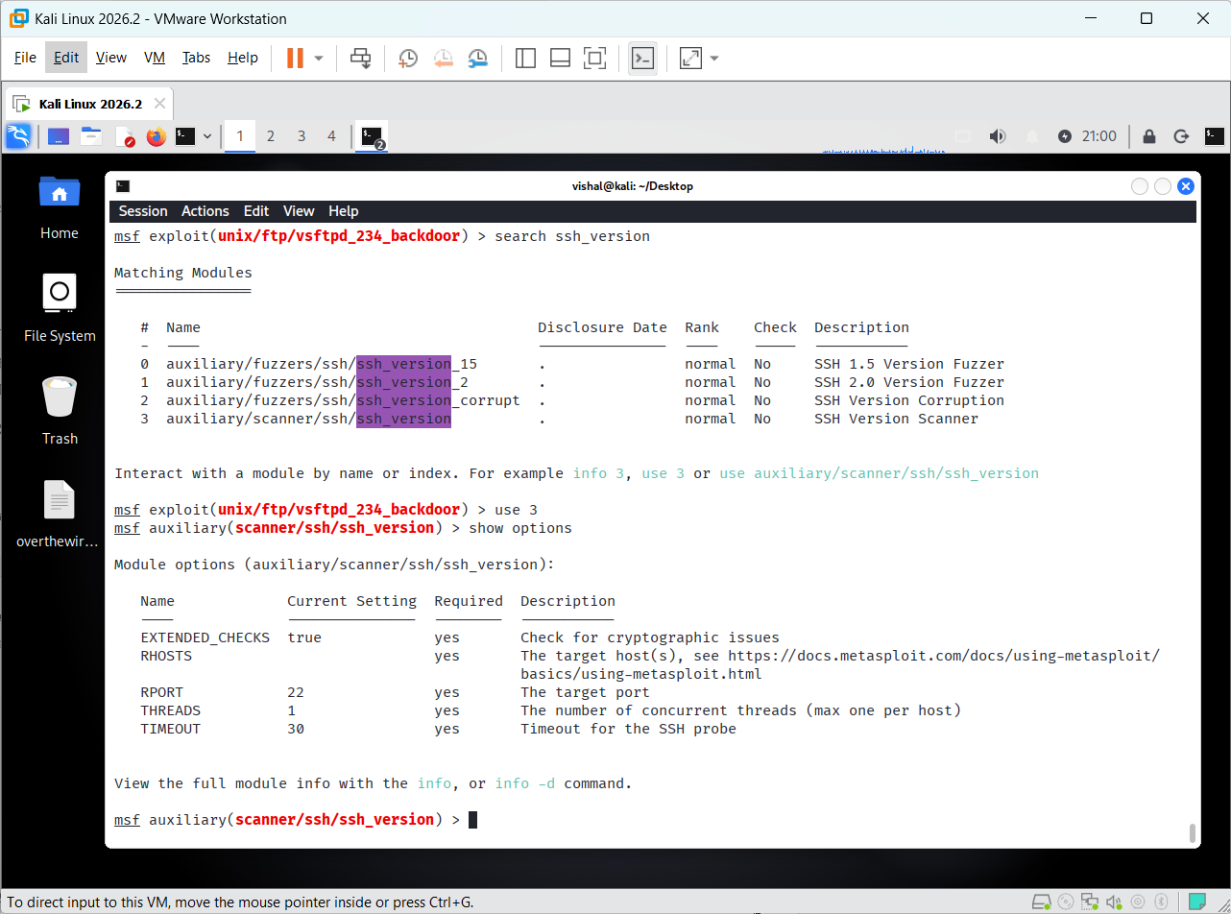
Screenshot 8: SSH Version Scanner Options

Explanation
The screenshot shows the SSH Version Scanner module selected in Metasploit. The show options command displays its configuration, including the required RHOSTS target address and the default SSH port 22. The module is ready to be configured for scanning the SSH service on the target system.
- RHOSTS — required target host.
- RPORT 22 — SSH service port.
- auxiliary/scanner/ssh/ssh_version in the Metasploit prompt to show the selected module.

Step 8: Configure and Scan the SSH Service
Since RHOSTS is required and currently empty, configure it with the Metasploitable 2 target IP: set RHOSTS 192.168.184.129
Then execute the SSH version scanner: run
The scanner will connect to TCP port 22 and identify the SSH service/version running on the target.
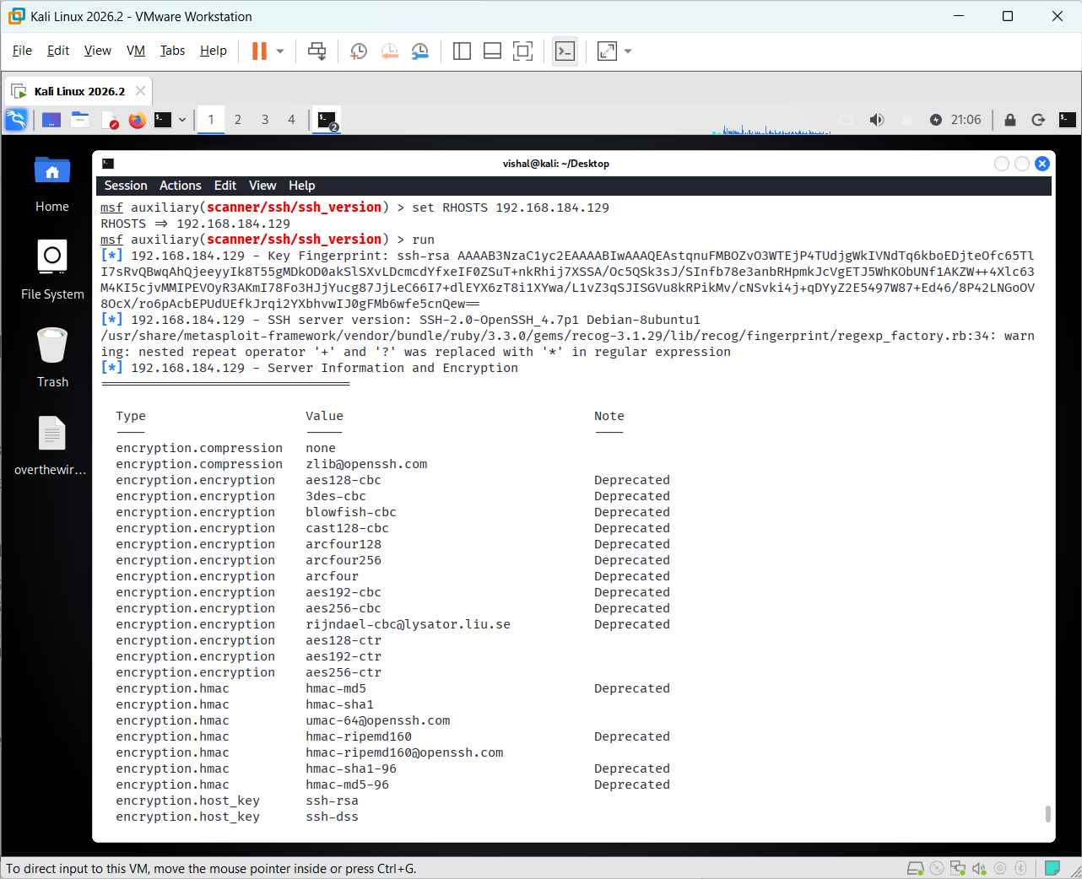
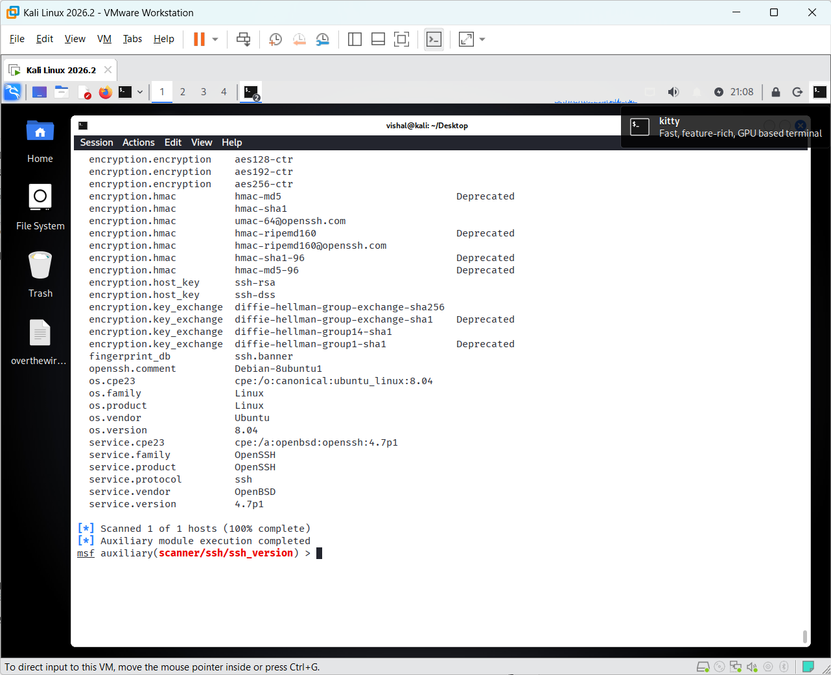
Screenshot 9: SSH Version Scan Result
Explanation:
The screenshot shows the completed SSH version scan and identifies the target's SSH service as OpenSSH 4.7p1 running on Ubuntu Linux 8.04. The scan completed successfully for the target host.
The identified SSH service and version are recorded as the result of the SSH enumeration phase.

Step 10: Select the SSH Login Scanner
The ssh_login module has been selected successfully, and show options displays the parameters available for testing SSH authentication.
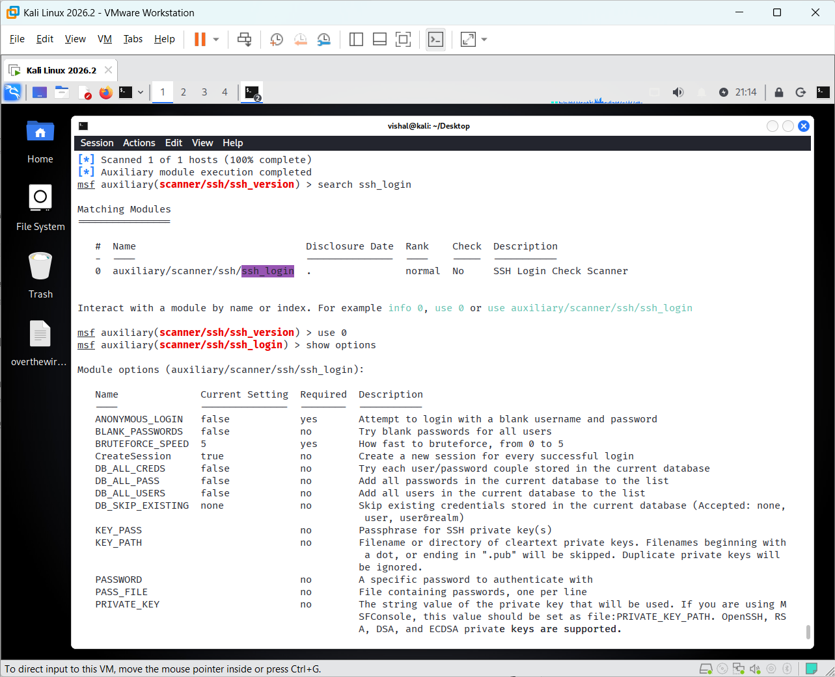
Screenshot 10: SSH Login Scanner Options
Explanation:
The screenshot shows the SSH Login Check Scanner module selected in Metasploit. The show options command displays the available authentication and target configuration parameters. The default SSH port is 22, while RHOSTS, USERNAME, and PASSWORD are available for configuring the authorized Metasploitable 2 login test.
The SSH login scanner is configured to test authentication against the authorized Metasploitable 2 SSH service using its default laboratory credentials.

Step 11: Verify Successful SSH Authentication
The SSH Login Scanner successfully authenticated to the Metasploitable 2 SSH service using the configured laboratory credentials and opened SSH session 1.
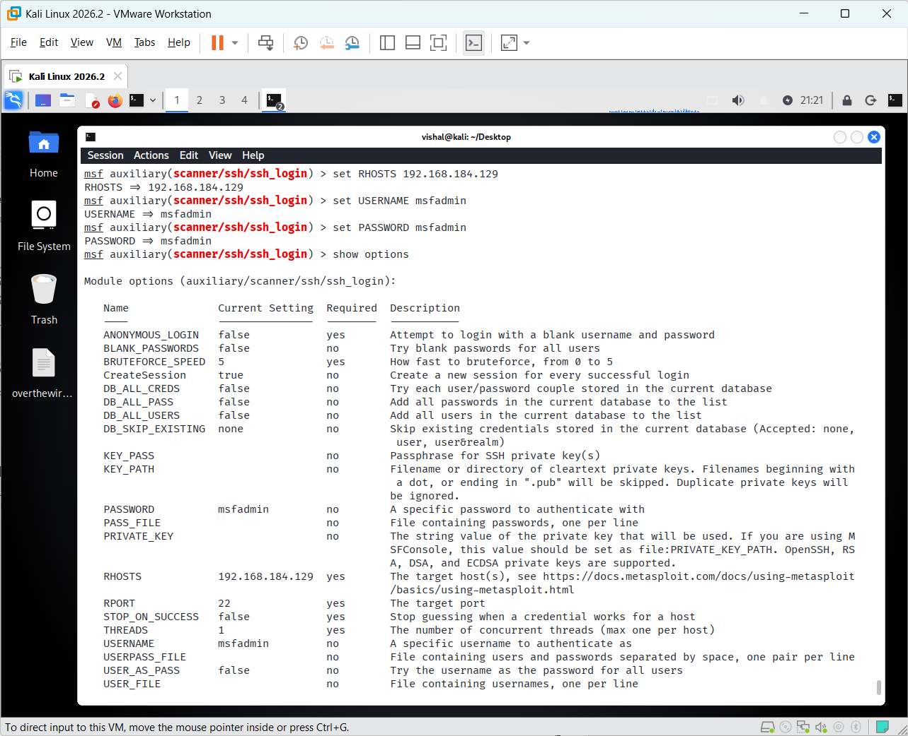
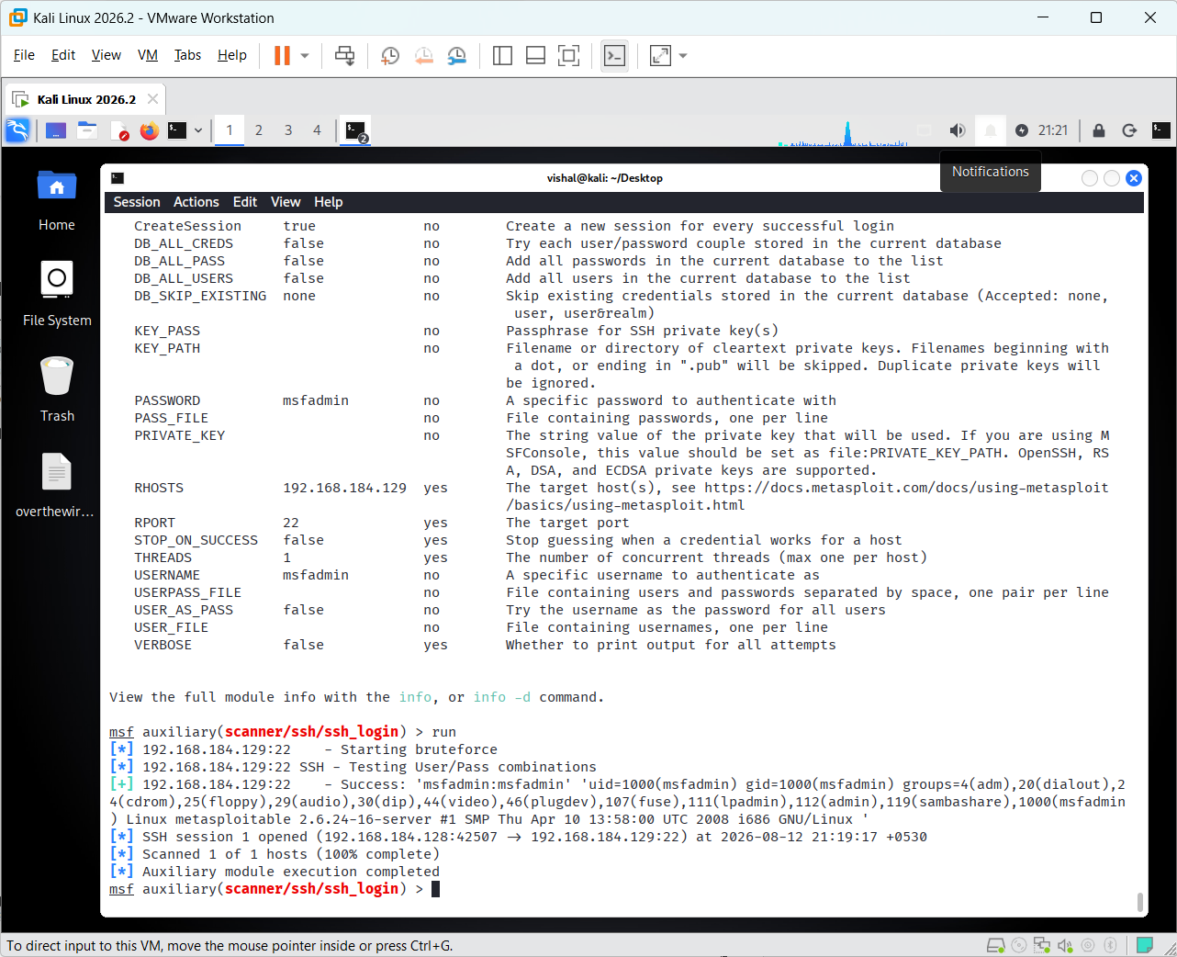
Screenshot 11: Successful SSH Login and Session
Explanation:
The screenshot shows the successful SSH authentication result. Metasploit reports the valid msfadmin credentials and confirms that SSH session 1 was opened. The output also displays system information identifying the target as the Metasploitable Linux system.
The successful SSH authentication and session establishment are recorded as evidence of successful SSH access to the authorized Metasploitable 2 laboratory system.

Step 12: Select the MySQL Version Scanner
From the Metasploit console, search for the MySQL version scanner: search mysql_version
The mysql_version module is identified and selected using: use 0
Then display its configuration: show options
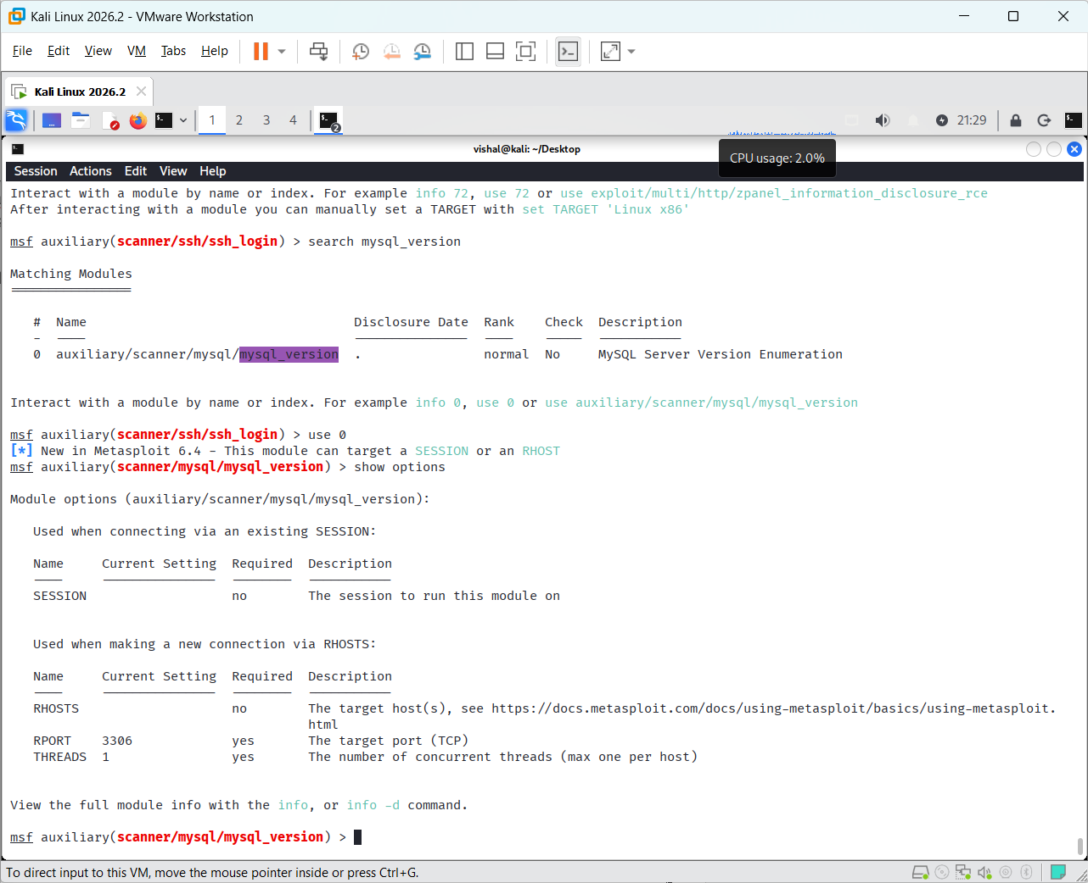
Screenshot 12: MySQL Version Scanner Options
Explanation:
The screenshot shows the MySQL Server Version Enumeration module selected in Metasploit. The show options command displays the available connection parameters. The module can connect using an existing session or directly to a target through RHOSTS; for a direct connection, the default MySQL port is 3306.
The MySQL Version Scanner configuration is reviewed before connecting to the MySQL service on the authorized Metasploitable 2 target.

Step 13: Access MySQL Database
From the Metasploit console, connect to the MySQL service using the available root account: mysql -h 192.168.184.129 -u root --skip-ssl
After successfully connecting, display the available databases: show databases;
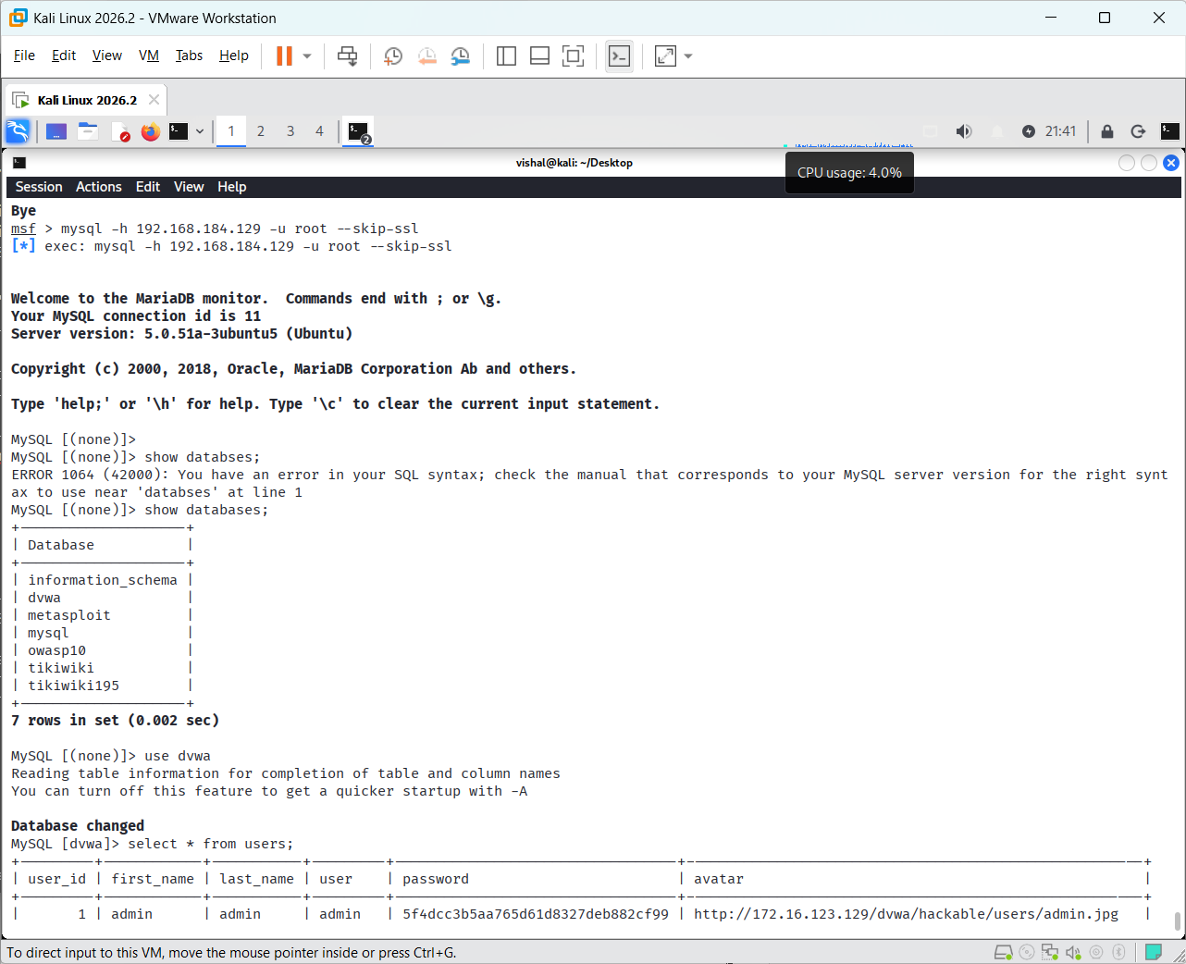
Screenshot 13: MySQL Database and User Records
Then select the dvwa database: use dvwa;
Finally, display the records from the users table: select * from users;
Explanation:
The screenshot shows a successful connection to the MySQL server and the available databases. The dvwa database is selected, and the users table is queried to display its stored records.
The successful MySQL connection, database enumeration, and retrieval of records from the dvwa database are recorded as evidence of database access in the authorized Metasploitable 2 environment.

Conclusion:
The practical successfully demonstrated the use of Metasploit (msfconsole) for security testing of FTP, SSH, and MySQL services on the authorized Metasploitable 2 environment. The vulnerable FTP service was exploited, SSH authentication was successfully tested, and MySQL databases and user records were accessed. This practical provided hands-on understanding of service enumeration, authentication testing, and exploitation in a controlled laboratory environment.

Practical-2

AIM: “Brute force attack using Hydra and Burpsuite”

A brute-force attack attempts to discover valid login credentials by systematically testing multiple usernames and passwords. Hydra is a network login password-testing tool that supports services such as FTP, SSH, and others. Burp Suite can be used to test web application authentication by intercepting and modifying HTTP requests. In this practical, both tools are used only against the authorized Metasploitable 2 laboratory system.

Step 1: Prepare Username and Password Lists
On Kali Linux, create the working directory and move to the Desktop: cd Desktop
Create a username list: nano user.txt
Add multiple usernames, including the valid Metasploitable 2 username.
Create a password list: nano pass.txt
Add multiple passwords, including the valid password.
The lists are then used by Hydra to test combinations against the authorized FTP service.
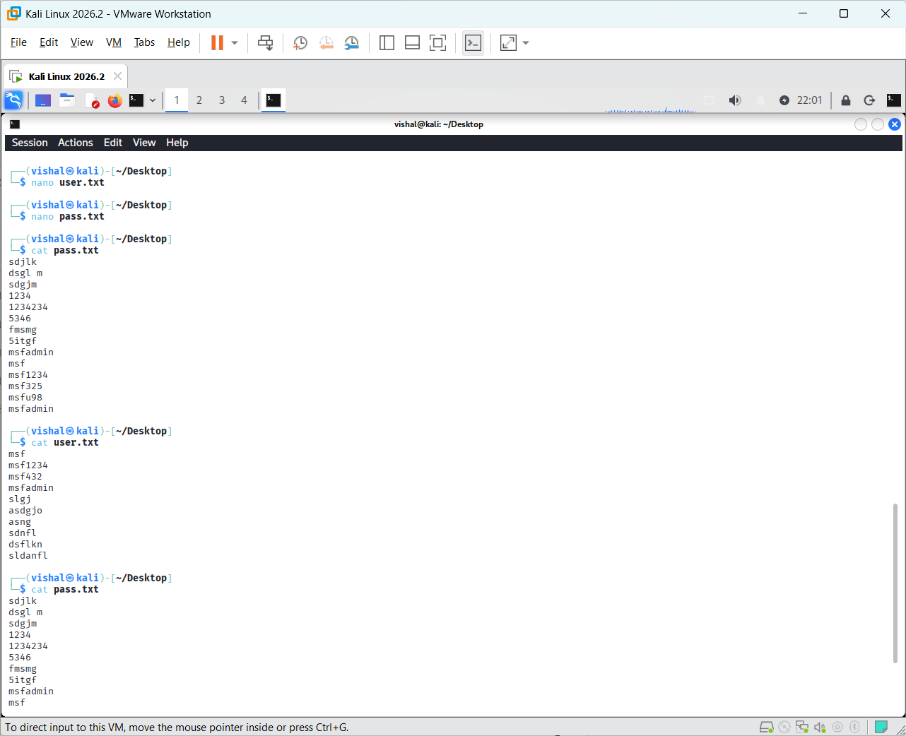
Screenshot 1: Username and Password Lists
Explanation:
The screenshot shows the prepared username and password lists used for the authorized brute-force testing activity.
The username and password lists are prepared for use with Hydra.

Step 2: Perform FTP Brute-Force Attack Using Hydra
The prepared username and password lists are supplied to Hydra using the -L and -P options:
hydra -L user.txt -P pass.txt ftp://192.168.184.129
Here, -L specifies the username list, -P specifies the password list, and ftp://192.168.184.129 specifies the authorized FTP target.
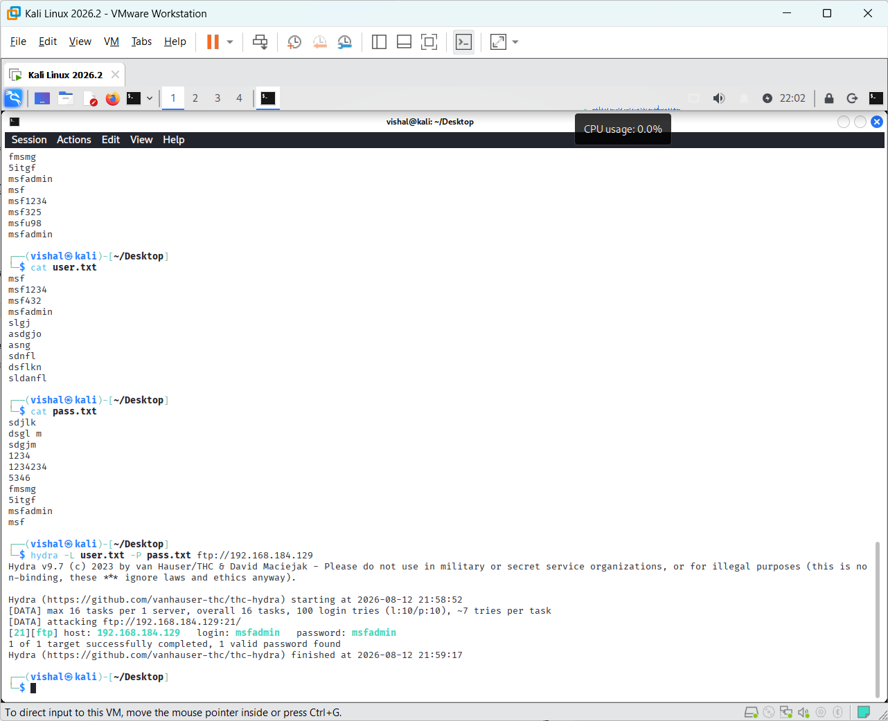
Screenshot 2: Successful FTP Brute-Force Result Using Hydra
Explanation:
The screenshot shows Hydra testing the supplied username and password combinations against the FTP service on the authorized Metasploitable 2 system. Hydra successfully identifies the valid credentials msfadmin:msfadmin and reports that one valid password was found.
The valid FTP credentials identified by Hydra are recorded as the result of the authorized brute-force testing.

Step 3: Configure Burp Suite for Web Login Testing
Now we move to the Burp Suite portion of the practical.
Start Burp Suite in Kali Linux and create/open a temporary project. Then go to:
Conclusion:

Practical-7

AIM: “Google Dorking [site:, inurl:, intitle:, address: and cache:]”

Google Dorking is a search technique that uses advanced search operators to locate specific information indexed by search engines. Operators such as site:, inurl:, intitle:, address:, and cache: can narrow search results and help identify publicly available information. In ethical hacking, Google Dorking is used during the reconnaissance phase to understand information exposed by an authorized organization or laboratory environment.
We will perform the practical one operator at a time, using safe and authorized search targets. For each command, I’ll provide only the search query + short explanation first, and later we’ll select the important screenshots.
Operators we will cover
- site:
- inurl:
- intitle:
- address:
- cache:
cache: availability depends on the search engine and may not return results because cached-page features have changed over time.
Step 1 — site: Operator
Search Google for: site:jio.com
The site: operator restricts the search results to pages indexed under the specified domain. Here, site:jio.com displays publicly indexed pages belonging to Jio's website.


Screenshot 1: site: Operator Search Result
Explanation:
The screenshot shows a Google search using the site:jio.com operator. The results are restricted to pages and subdomains associated with the Jio domain, demonstrating how the site: operator can be used to limit search results to a specific website.

Step 2 — inurl: Operator
Search Google for: site:jio.com inurl:login
The inurl: operator searches for pages where the specified term appears in the URL. Here, inurl:login looks for Jio-domain pages whose URL contains the word login.

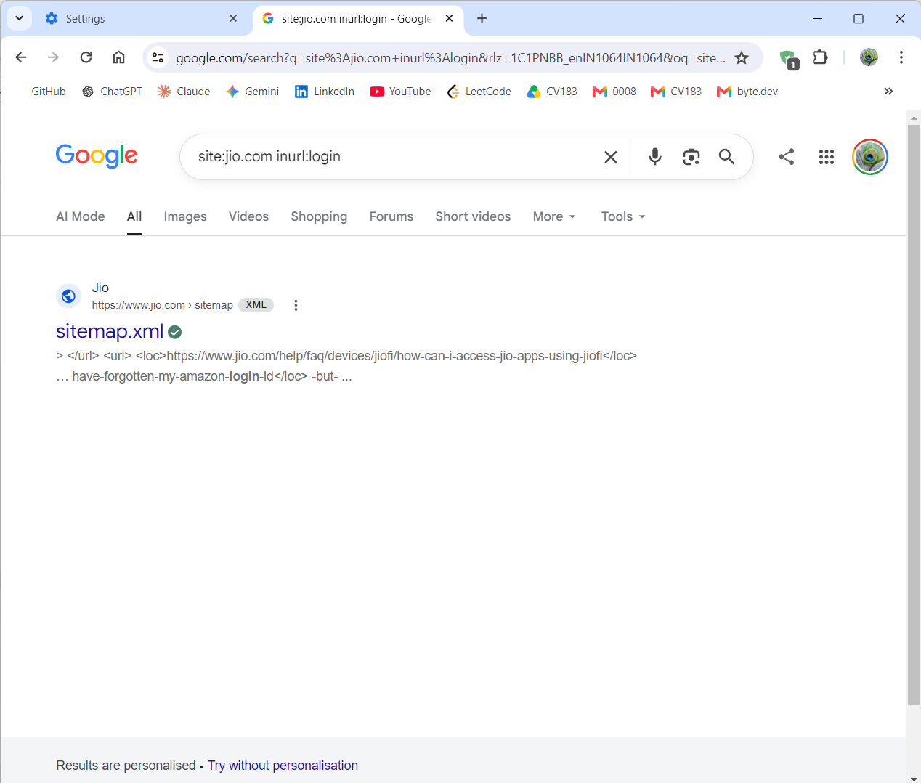
Screenshot 2: inurl: Operator Search Result
Screenshot Explanation:
The screenshot shows a Google search using site:jio.com inurl:login. The search is restricted to the Jio domain, while inurl:login searches for the term “login” in URLs indexed by Google. The result shown is sitemap.xml, where the search result snippet contains a URL containing login-id.

Step 3 — intitle: Operator
Search Google for:
site:jio.com intitle:login
The intitle: operator searches for pages where the specified word appears in the page title. Here, intitle:login looks for Jio pages with “login” in their title.
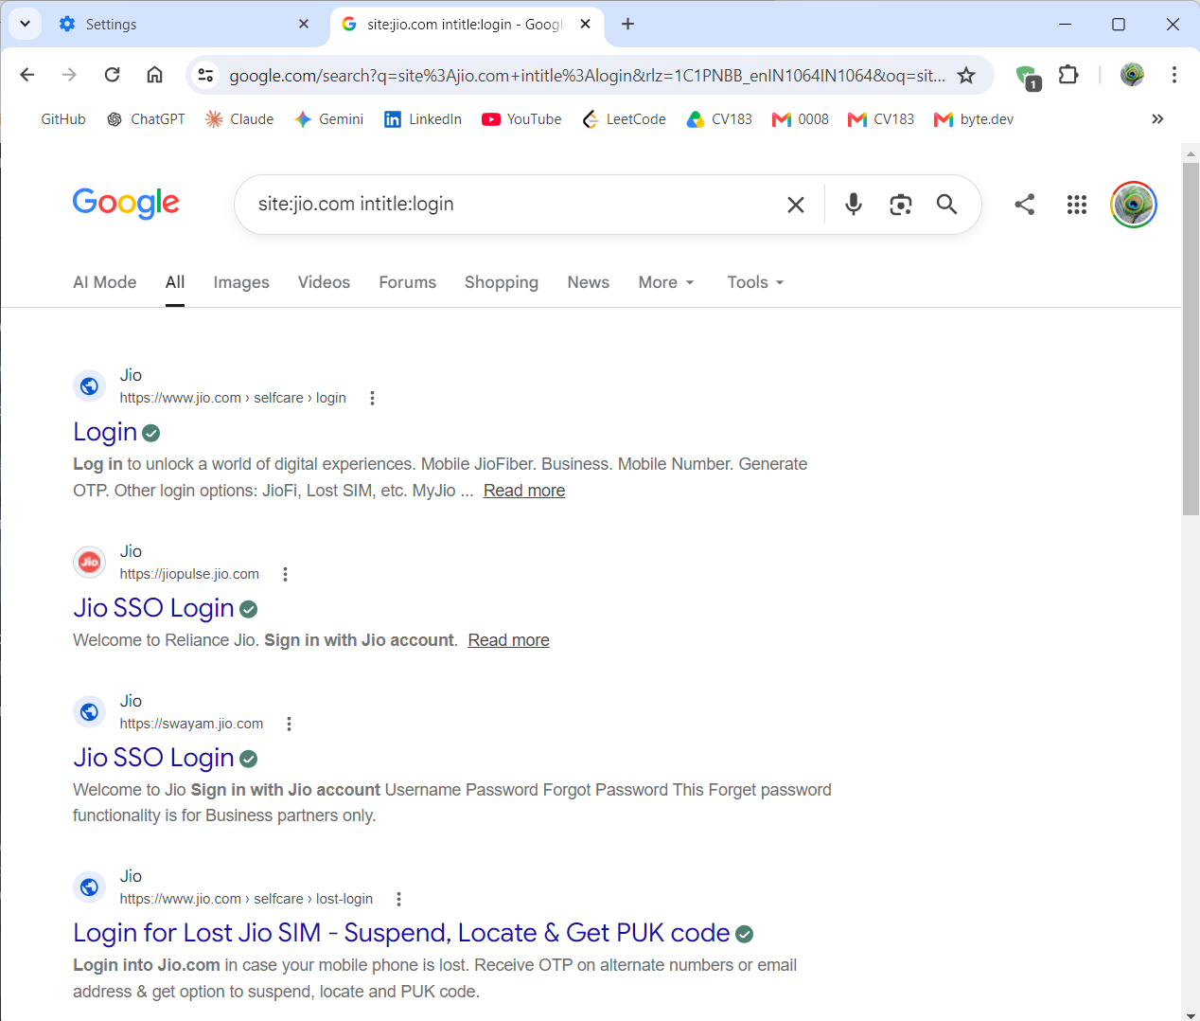
Screenshot 3: intitle: Operator Search Result
Screenshot Explanation:
The screenshot shows a Google search using site:jio.com intitle:login. The results are restricted to Jio-related domains, and the intitle:login operator returns pages with “Login” in their page title. Several login-related Jio pages are visible in the results.

Step 4 — address: Operator
Search Google for:
site:jio.com address:jio
The address: operator can be demonstrated as a search keyword for finding pages containing the specified address-related term. Here, address:jio is combined with site:jio.com to keep the search focused on Jio-related results.

Screenshot 4: address: Search
Screenshot Explanation:
The screenshot shows the Google search query site:jio.com address:jio. The results are restricted to Jio-related pages and include publicly indexed contact/location information, such as Jio customer-care details, store/service-center information, and a registered-office address.

Step 5 — cache: Operator
Use this query:
cache:jio.com
The cache: operator was historically used to access Google's cached copy of a webpage. However, Google no longer provides the traditional cached-page feature, so this query may return no useful cached result.
If Google shows no cached result, take a screenshot of the search result/no-result page as evidence that the traditional cache: feature is unavailable.

Conclusion:
The practical successfully demonstrated Google Dorking techniques using the site:, inurl:, intitle:, address:, and cache: operators. These operators helped narrow Google search results and identify publicly indexed information related to the Jio domain. The practical also demonstrated that the traditional Google cache: feature is no longer generally available.

Practical-8

AIM: “Nmap all important options”

Nmap (Network Mapper) is a network scanning tool used to discover hosts, identify open ports, detect services, and gather information about network systems. It provides different scanning options for performing host discovery, port scanning, service/version detection, and operating system detection. In this practical, important Nmap options are demonstrated in an authorized lab environment using Kali Linux and Metasploitable 2.
Planned important Nmap options
We'll cover the useful options rather than literally every Nmap option:
- nmap <target> — basic scan
- -sS — TCP SYN scan
- -sT — TCP Connect scan
- -sU — UDP scan
- -p — specific port
- -p- — all TCP ports
- -F — fast scan
- -sV — service/version detection
- -O — OS detection
- -A — aggressive scan
- -Pn — skip host discovery
- -n — disable DNS resolution
- -T4 — faster timing
- -oN — save output to a normal text file

1. Basic Scan
nmap 192.168.184.129
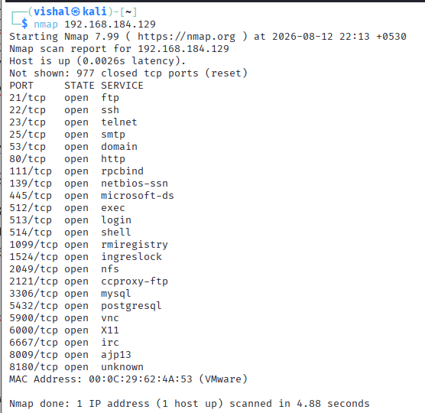
Explanation:
Performs a basic TCP port scan against the authorized Metasploitable 2 target and identifies commonly scanned open ports.

2. SYN Scan
nmap -sS 192.168.184.129
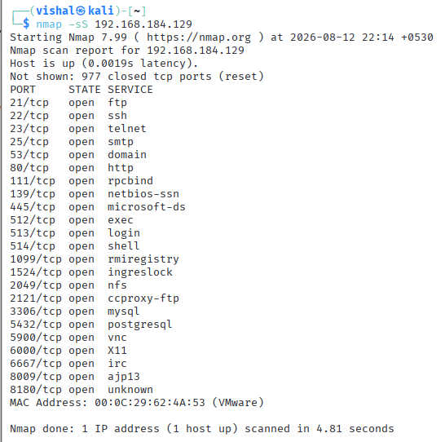
Explanation:
Performs a TCP SYN scan to identify open TCP ports. It sends SYN packets and analyzes the responses without completing the normal TCP connection.

3. TCP Connect Scan
nmap -sT 192.168.184.129
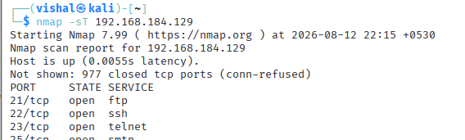
Explanation:
Performs a TCP Connect scan that completes the TCP connection with the target to determine whether ports are open.

4. Scan a Specific Port
nmap -p 21 192.168.184.129
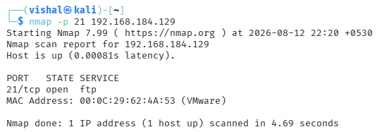
Explanation:
Scans only TCP port 21, commonly used by FTP, to determine whether the port is open on the target.

5. Scan Multiple Specific Ports
nmap -p 21,22,80,3306 192.168.184.129
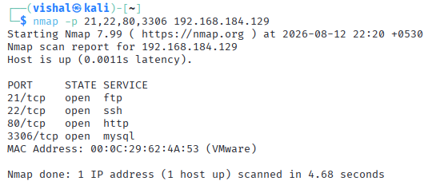
Explanation:
Scans the specified ports individually. This is useful for checking particular services such as FTP (21), SSH (22), HTTP (80), and MySQL (3306).

6. Scan All TCP Ports
nmap -p- 192.168.184.129
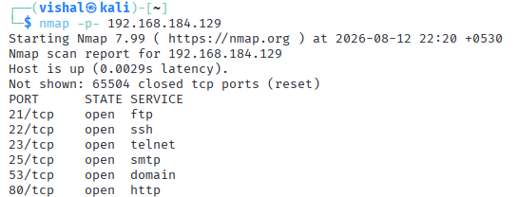
Explanation:
Scans all TCP ports from 1 to 65535 instead of only Nmap's default commonly scanned ports.

7. Service Version Detection
nmap -sV 192.168.184.129
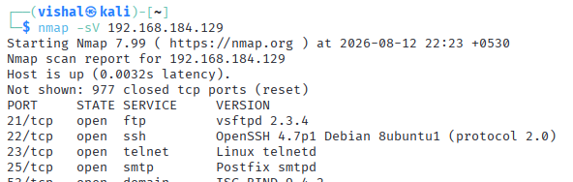
Explanation:
Detects the service name and version running on open ports, such as FTP, SSH, HTTP, or MySQL.

8. Operating System Detection
sudo nmap -O 192.168.184.129
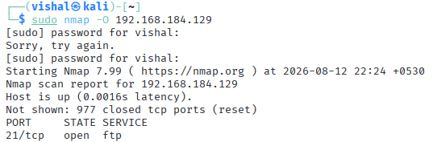
Explanation:
Attempts to identify the operating system and its version based on the target's network responses.

9. Service + OS Detection
sudo nmap -sV -O 192.168.184.129
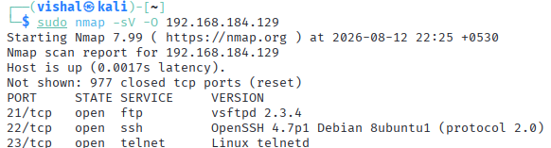
Explanation:
Combines service/version detection with operating-system detection to gather more detailed information about the authorized target.

10. Aggressive Scan
nmap -A 192.168.184.129
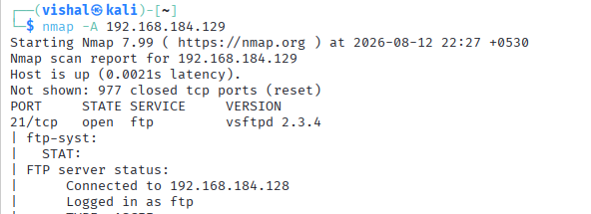
Explanation:
Performs an aggressive scan that combines several detection techniques, including OS detection, service/version detection, script scanning, and traceroute.

11. Skip Host Discovery
nmap -Pn 192.168.184.129
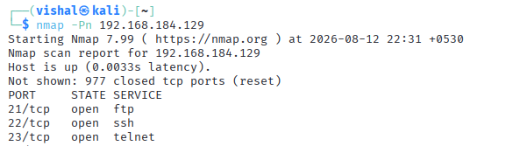
Explanation:
Skips the initial host-discovery phase and treats the target as online. This is useful when a target does not respond to normal host-discovery probes.

12. Disable DNS Resolution
nmap -n 192.168.184.129
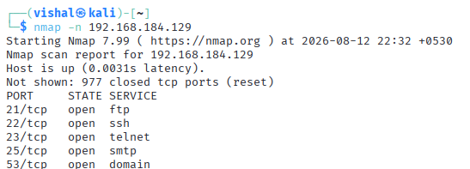
Explanation:
Disables DNS resolution during the scan, which can reduce unnecessary lookup time and display results without resolving hostnames.

Nmap — Command Group 5: Timing and Output
13. Faster Timing
nmap -T4 192.168.184.129
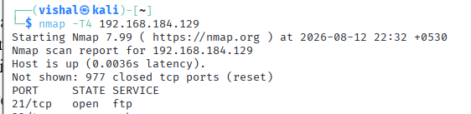
Explanation:
Uses Nmap's T4 timing template to perform the scan faster. Timing options control how aggressively Nmap sends probes.

14. Save Results to a Text File
nmap -sV 192.168.184.129 -oN nmap_result.txt
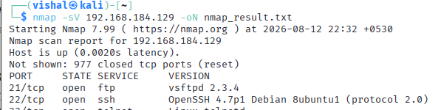
Explanation:
Performs service/version detection and saves the scan output in normal human-readable format to nmap_result.txt.

Conclusion:
The practical successfully demonstrated the use of Nmap for network reconnaissance and service enumeration in an authorized laboratory environment. Various Nmap options were used to perform basic port scanning, service and version detection, operating system identification, targeted port scanning, aggressive scanning, and output saving. The practical provided hands-on experience in gathering network information, which is an essential step in ethical hacking and penetration testing.

